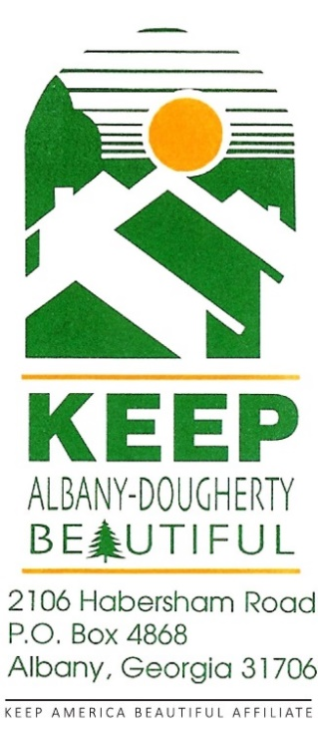
Keep Albany-Dougherty Beautiful

January | 1-31 | Recycling in the Workplace Campaign
 |  | Environmental Tabloid inserted in The Albany Herald
 | 22 | Volunteer Luncheon
February | 20 | School Arbor Day Celebration
 | 21 | County Arbor Day
 | 23 | Tree Walk w/ Edward Morrow @ Live Oak Elementary and Lincoln Elementary
March | 17/18 | Water Festival for 3rd Grade students (Civic Center)
April | TBD | Tree Pruning
 | 16-18 | Great American Clean-up/Stash-The-Trash
May | 2 | Shredding Event (9:00 AM – 1:00 PM Civic Center)
July | TBD | Limb up City Crape Myrtles (Westover Blvd.)
September | 12 | Electronic Recycling, Paper Shredding & Operation Pill Drop  (9:00 AM – 1:00 PM Civic Center back parking lot)
October | 3 | Rivers Alive
 | TBD | Limb Up City Crape Myrtles (Westover Blvd.)
November | 15 | America Recycles Day
2026 Calendar of Events

